**CN LAB 3 REPORT**

**Router Configuration (Creating Passwords, Configuring Interfaces)**

**Experiment Overview:**

In this experiment, you will configure a router and two PCs using Cisco Packet Tracer.

The computers are connected to the router using copper straight-through cables. After

setting up the network, you will test the connectivity by sending a simple PDU from PC0

to PC1. The successful simulation will demonstrate the router's capability to handle data

transfers between multiple devices.

**Network Topology Design**

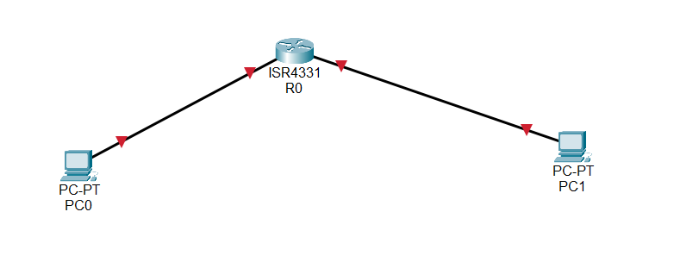

**Procedure:**

Step 1: Dragged a ISR4331 Switch and 2 PCs on to the canvas and used Copper Cross-over cable to connect each PC’s port FastEthernet0/0 to the router’s GigabitEthernet0/0/0 and 0/0/1 respectively.

Configuring Router1

1. Select the router and open CLI.

2. Press ENTER to start configuring Router1.

3. Activate privileged mode:

○ Type enable

4. Access the configuration menu:

○ Type config t (configure terminal)

5. Configure interfaces of Router1:

○ FastEthernet0/0:

■ Type interface FastEthernet0/0

■ Configure with the IP address 192.168.10.1 and Subnet mask

255.255.255.0

○ FastEthernet0/1:

■ Type interface FastEthernet0/1

■ Configure with the IP address 192.168.20.1 and Subnet mask

255.255.255.0

6. Finish configuration:

○ Type no shutdown to activate the interfaces

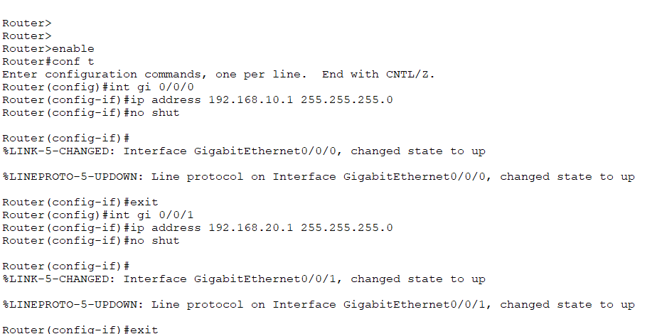

Command Line Interface of the router

Step 2: Configuring PCs

1. Assign IP addresses to each PC:

○ PC0:

■ Go to the desktop, select IP Configuration, and assign the following:

■ IP address: 192.168.10.2

■ Subnet Mask: 255.255.255.0

■ Default Gateway: 192.168.10.1

○ PC1:

■ Go to the desktop, select IP Configuration, and assign the following:

■ IP address: 192.168.20.2

■ Subnet Mask: 255.255.255.0

■ Default Gateway: 192.168.20.1

Step 3: Connecting PCs with Router

1. Connect the devices using copper straight-through cables:

○ Connect FastEthernet0 port of PC0 to FastEthernet0/0 port of Router1

○ Connect FastEthernet0 port of PC1 to FastEthernet0/1 port of Router1

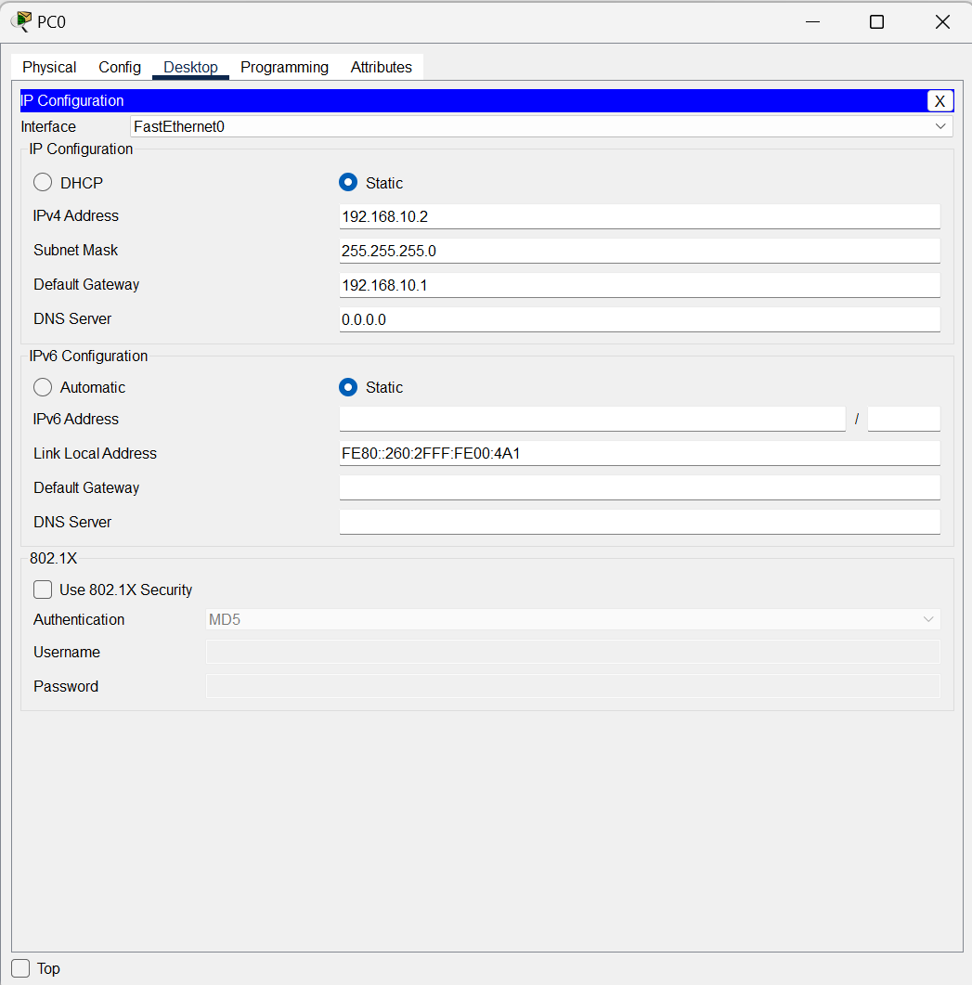

Assigning IP address to PC0

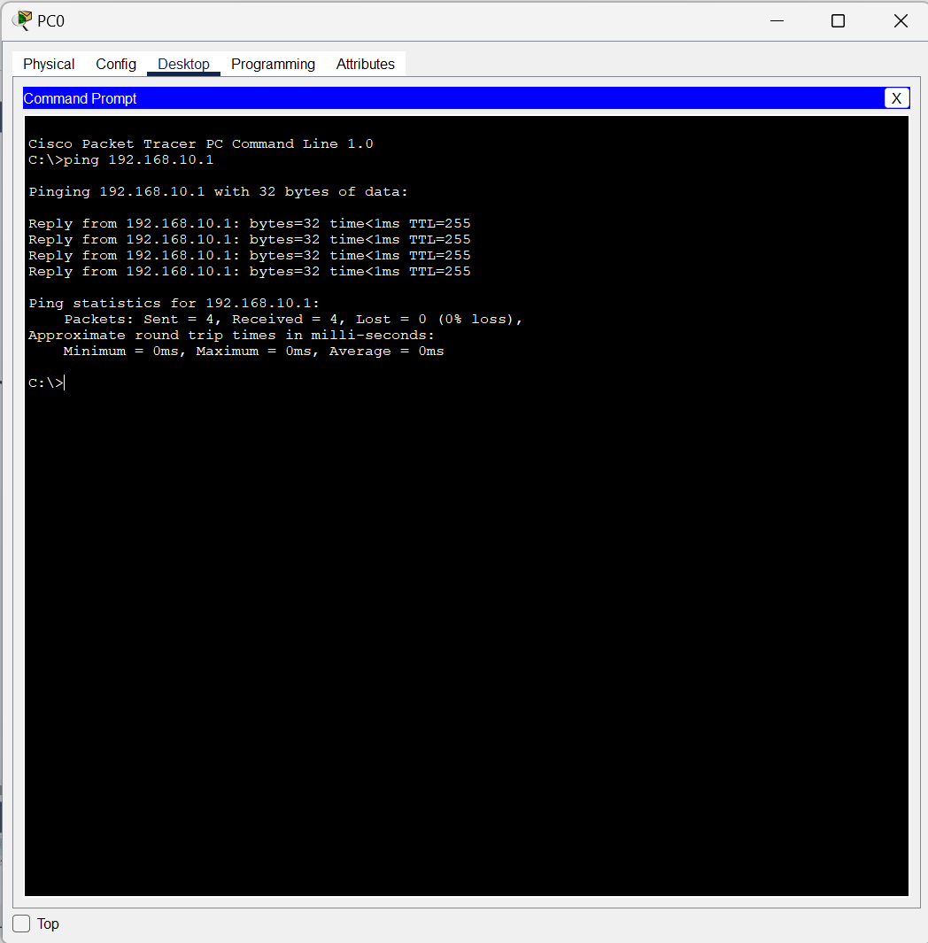

Successful ping message from PC0 to PC1

**STEP 3:**

BASIC ROUTER SETUP

Setting passwords/authentication to the router

